

Azure Fundamentals

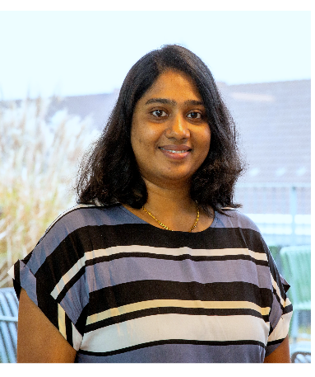

**PERSONAL**

**INFORMATION**

Lykkens minde 10

aswini.sureddy@gmail.com

+45 71504794

**LANGUAGE**



English

-

Fluent



Danish

-

intermediate

**LINKEDIN**

https://www.linkedin.com/in/asw

ini-sureddy/

**PORTFOLIO**

https://aswinisureddy-

profile.netlify.app

**CERTIFICATIONS**

Frontend Developer

Azure Fundamentals

Azu

**Aswini Sureddy**

Frontend Developer

**SUMMARY**

Proficient in HTML5, CSS3, and JavaScript, with a solid foundation in

responsive web design and modern frontend frameworks like React.

Strong problem-solving skills and a collaborative mindset, adept at

working in cross-functional teams to deliver high-quality web applications.

Eager to leverage my skills and contribute to innovative projects while.

continuously learning and staying updated with the latest frontend

development trends and best practices.

**TECHNICAL SKILLS**

Proficient in HTML5, CSS3, JavaScript, SQL Coding

Experience with frontend frameworks such as React.

Strong understanding of responsive web design and mobile-first

development.

Knowledge of version control systems like Git.

Solid understanding of web accessibility standards (WCAG) and

SEO principles.

Experience with performance optimization techniques.

Ability to collaborate with designers to translate UI/UX wireframes.

into functional code.

Excellent problem-solving and debugging skills.

**EXPERIENCE**

**Frontend Developer 2021 -2022**

During my study I developed many web and mobile responsive applications.

Created web applications using HTML, CSS, and JavaScript, ensuring cross-

browser compatibility and optimal performance. Have good experience in

integration of frontend components with backend APIs by ensuring

seamless data flow and efficient data exchange.

Applications created: Weather App, Office store and Portfolio.

**Frontend Developer (Self Learning Projects)** **2022 –** **2023**

* Live Weather App Technologies used: HTML, CSS, node.js, react, SEO, API, Bootstrap
* Office Store – Shopping cart application Technologies used: HTML, CSS, and JavaScript
* Simple Yoga Page Technologies used: HTML, CSS, SEO

Good Knowledge in Python, Power BI & Tableau

**EDUCATION EQUIVALENCY**

**My Indian bachelor’s degree in it is recognized as equivalent to a Danish Bachelor's degree by Danish 'Uddannelses- og Forskningsstyrelsen' based on a curriculum and credit hour comparison.**

**Course relevant to the equivalence: Danish Bachelor's Degree.**

**EDUCATION**

**Bachelor of Technology (B-tech)**

5-2008

-

4-2012

*University JNTU, India*

*•*

*Information Technology*

Study Focus: Computer Programming(C), IT Workshop, UNIX And Shell

Programming, DATA Structures & Algorithms, Operating Systems,

Database Management Systems, Object Oriented Programming, Web

Technology’s.

**COURSE**

**Frontend Developer**

*2021 - 2022*

*2021 - 2022*

Denmark

Aadvanced concepts and best practices for developing web applications.

Using React Topics covered included React, hooks, context API, state-

management, asynchronous programming with Redux, and integration

with backend APIs.

**Cloud Computing (Azure Fundamentals)**

*2023*

Denmark (Redi school)

Cloud computing, covering various topics, including cloud architecture,

virtualization, infrastructure as-a-service (IaaS), platform-as-a-service (PaaS),

and software-as-a-service SaaS). Hands-on exercises were conducted.

(

on popular cloud platforms. Like Amazon Web Services (AWS) and

Microsoft Azure.